IS51016A: Audio Visual Computing

Coursework 2 Report

Matthew Sellman (33317514) / William Chanter (33353254)

https://github.com/williamchanter/ParticleAccerlorator/

Executive Summary

The quality of our projects practical use is very high indeed. Our project consists of a particle simulator, the outputs we need from this would be to create new elements or ‘discover old ones. In order to make this possible we have two ‘beams’ or lines of ellipses which, when colliding, they create another stream of particles going from the collision source into random directions. The program also comes with sound, 3d and lighting, with other effects that we learned from our audio-visual lectures and labs.

Note: The simulation is accurate in the fact is close to impossible to successfully fuse elements together, so an image of the game with the sliders correct position has been included.

Features and User Interactions

We wanted to develop this kind of project because we thought it would, first of all, be a useful thing to have. Secondly, we wanted something that was fun and educational that would be interesting to play and would be informative to others. Finally, we wanted something that we could, if we wanted to, expand later on. There’s only so far the project can go but the ability to add different things onto it is really something that was important to us.

We wanted to use all, or most of the things we had been taught in audio-visual lectures and labs, and we thought that the best way to do this was a particle simulator, this would incorporate gravity, sound, collisions and effects from those collisions. We decided the particle simulator would be the best way in which we could incorporate this.

Our project is mainly based on the interactions of two beams of particles that can be controlled using p5 controls. When these two particles make contact they then split and each half joins the other, while doing this they also shoot out green particles. These green particles are on a smaller scale than the other two beams, they originate from the contact point and shoot out in any direction (due to 3d).

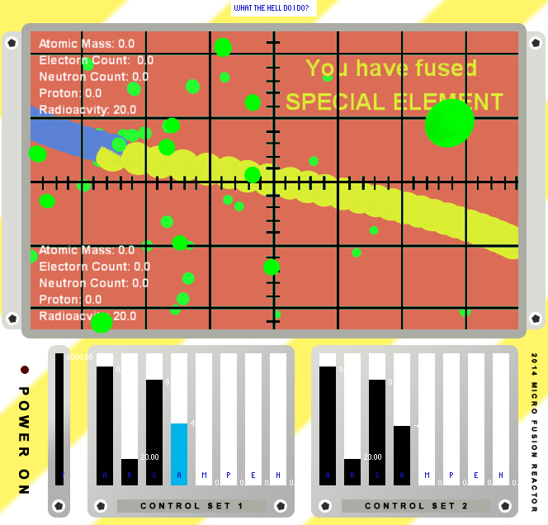
Another interaction within our project is the ability for the user to change the outcome of the experiment, the user’s choice of angle, velocity and other constraints will change the outcome. We wanted this level of interaction with the user because it meant that we could keep the game interesting and informative. You can see on the left a screen shot of the simulator, you can see that the user has the option to control and interact in a number of way with the sliders and also they can pan and tilt the camera to see the reaction for a different view.

When the user finally get the correct combination of slider values they will see which elements has been created.

The user is also able to see the value which the slider is effecting on the side menu of the simulator.

Another area of interaction is at the very top where the user can bring up there gaols. This is shown in a console style design.

Development

Make sure to include any key comments in your code snippet as well.

Our code is structured into tabs with separate classes and methods in them. Our first tab is called simulator and it’s here that the main part of our code is. At the top we have import the controlP5 [1] library and the minim library [2], plus the sound system and the inbuilt processing camera [3] (see references and external resources). These allow us to have the particles and the controls, both of which are absolutely vital in working the program. After that we have our variables, these include 2 sets of variables, one for the left hand beam and the other for the right hand beam. Each variable, angle, speed, radiation (radio) and acceleration affects the beam in some way and alters the result of the program. The early part (void setup) of the program is setting the size, position and values for these controls, see below and example from acceleration 1:

These will set the position and values of the controls, as well as the colour of the controls themselves. The position is the position of the slider, the size is the sliders visual size on the processing window. The range of the slider represents the … whereas the value of the … the colour of the slider and the colour of the label.

cp5.addSlider("acc1")

.setPosition(150, 430)

.setSize(20, 160)

.setRange(0, 1)

.setValue(0.9)

.setColorCaptionLabel(color(20, 20, 200));

After that we have void draw, which starts with the background to make the background continuously adjust so moving shapes don’t leave an imprint behind them. Immediately after that there’s the push matrix and inbuilt processing camera. We used this because it would allow us to change the camera. The same goes for the if statement that allows the user to decide when to use the camera and when it is possible to look around the 3D environment. The same goes for the next section of code, in this we can see the frame count being used to stop processing from crashing if too many particles are on screen. After that the camera and matrix ends. Void layout and void conPannel both make up the controls at the bottom of the screen, either by changing the colours or by making the rectangles that form the background. After this comes mouseDragged, this makes the camera spin activate using a Boolean variable.

Our second tab is called particle, once again we have the class and variables followed by the constructor. After this there is the void run, void update and void display, each of which forms the two beams for the program. These include the use of rotation, a push and pop matrix, not to mention lights and interacting functions. After this comes the Boolean for the array and the removal of particles that go outside the space of the screen. For example, if the location.x of the particle goes over a certain point, then it will cease to exist.

After this piece of code there comes the Boolean for removing the particles, where the false value deletes them.

boolean detect(ArrayList<Particle> _p2) {

for (int i = 0; i < _p2.size(); i++) {

Particle _particle1 = _p2.get(i);

if(

location.x < _particle1.location.x+10 &&

location.x > _particle1.location.x-10 &&

location.y < _particle1.location.y+10 &&

location.y > _particle1.location.y-10

)

This next tab is called particle creations and follows the same vein as the last particles tab. The only difference is that this tab, particleCreations, creates the offshoot particles and therefore has a different colour to the particle tab.

The last tab is called Particle_Draw, it’s here that everything comes together. Starting once again with the class, variables and constructor as well as an array. Then we come to void run where a backwards for loop removes any dead particles. After that addparticleoff creates new particles when the old ones have been deleted. The next void Runoff is where the off shoot particles are made and destroyed once again using a for loop. The final part of the code is the detectBeam function. This calls the removal of particles and detects if particles have died or not.

Our external resources include the controlP5 library which allowed us to put some nifty controls onto the program. This was incredibly helpful to use and saved a lot of time that could be devoted to making the collisions between the particles perfect. In the same way we used P5 controls we also used particle systems and the inbuilt camera from processing. This allowed us to add a third, more interactive element to the program. Further to this we also used processing-sound in order to put sound into our program, in addition to this we have the minim library that allowed us to incorporate the sound into the program using the audio player.

Another key area of development was the creation of a particle, this was the key goal of the game. The example below shows the creation of Francium:

if (atomicMassTOP + atomicMassBOT == 223 && electronTOP + electronBOT == 87/electronCount && neutronTOP + neutronBOT == 137 && protonsTOP + protonsBOT == 87 && roomTemp == 2896) {

powerupStyle("You have fused\n FRANCIUM");

}

You can see the user had to get a very specific set of variable in both streams to create an element. This information was taken of the periodic table (only this element) to add a sense of real life.

Overall the development of the project to some time and in the end produced a successfully project. The project achieved what it set out to achieve in that it allowed the user to experience the complexity of creating fusion.

References

[1] P5 library is available at: http://www.sojamo.de/libraries/controlP5

[2] Minim library is available at: http://code.compartmental.net/tools/minim/

[3] Sound library is available at: https://github.com/processing/processing-sound

